**Student Management System**

**Using ASP.NET MVC**

1. This is the first page if you open first, it will open Login Page

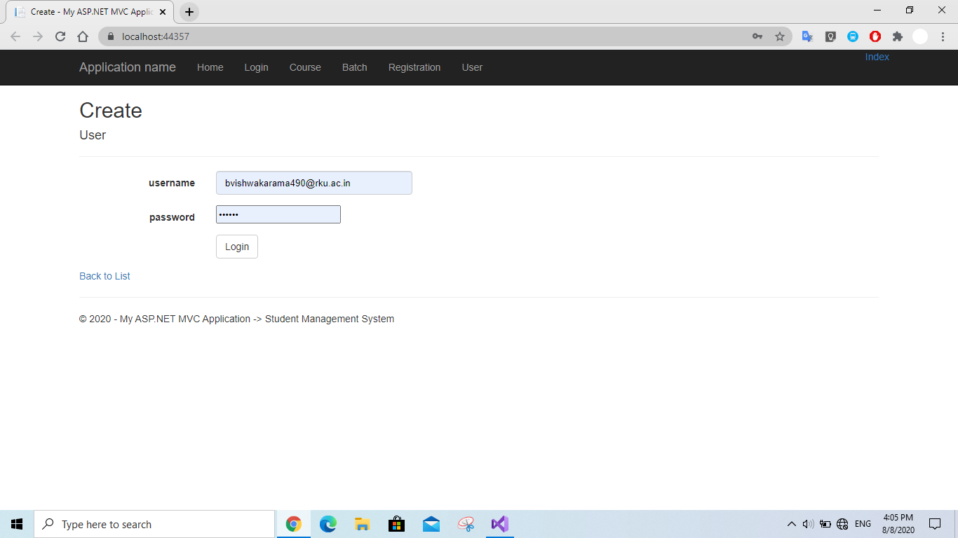

1. After entering credentials you will redirect to the Home page where all the details about this project is mentioned.

There you will find a YouTube video link below from where I created this project and you can get better explanation and if you want to create it you can by watching the video.

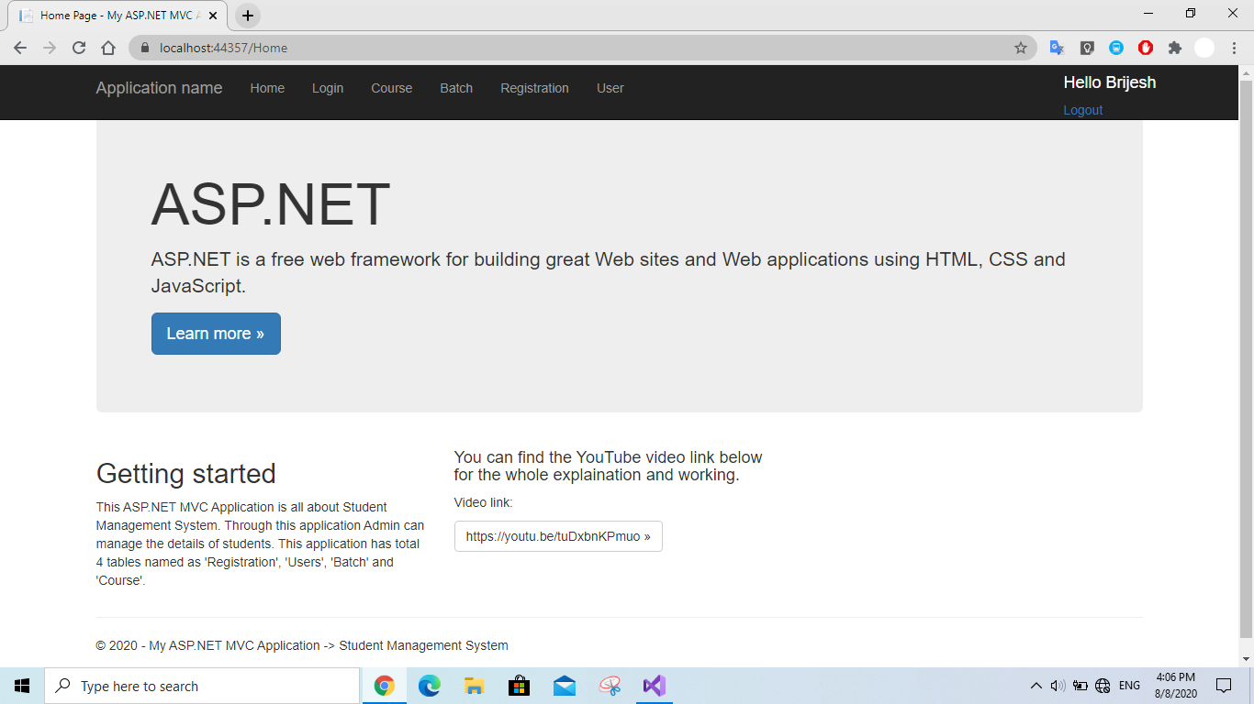

1. If you are not a user then you can register yourself by clicking “User” button in navigation bar and then click ‘Create’ button.

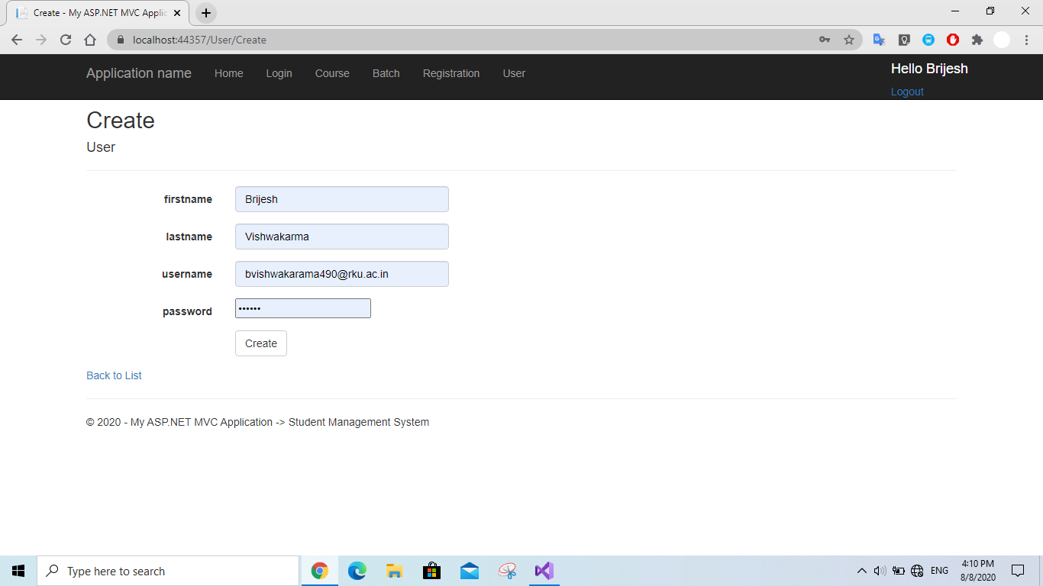

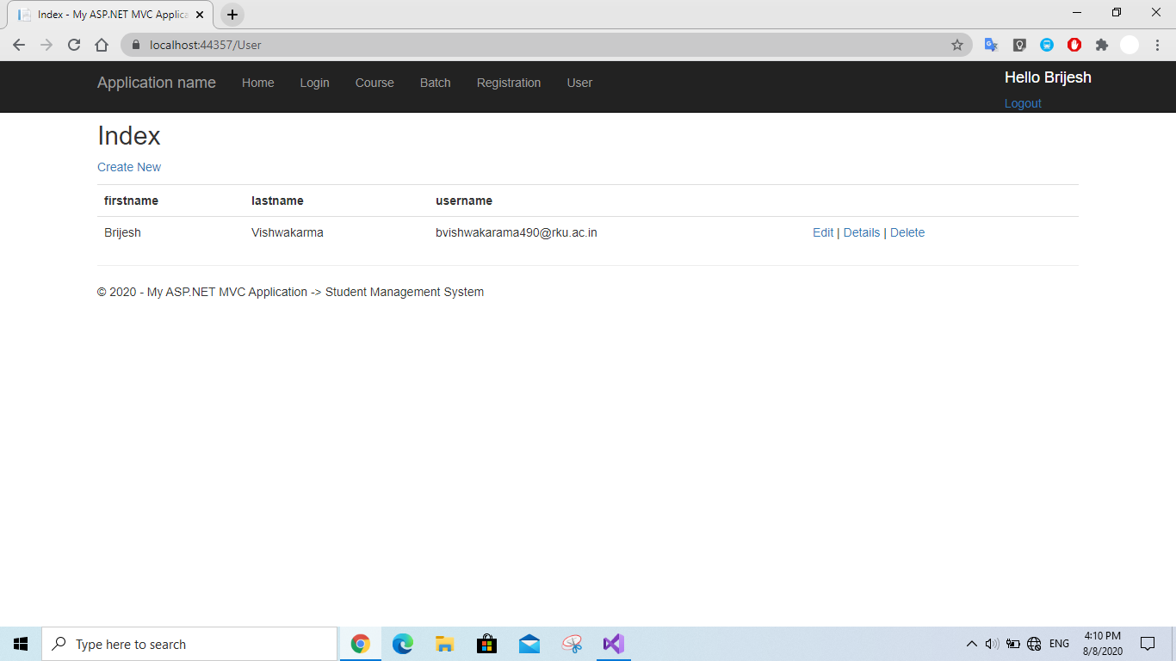

1. In ‘Course’ page you can add course and year by clicking “Create”. You can find the list as well.

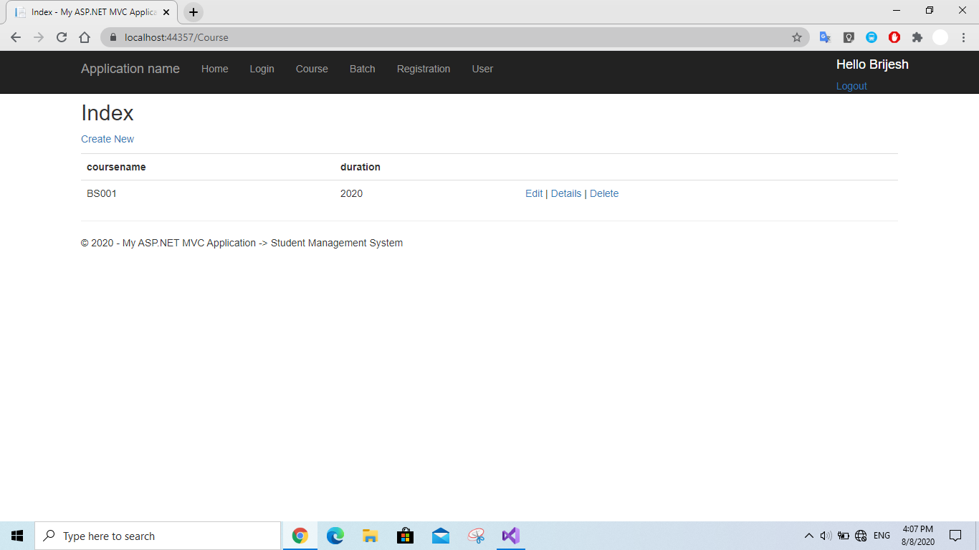

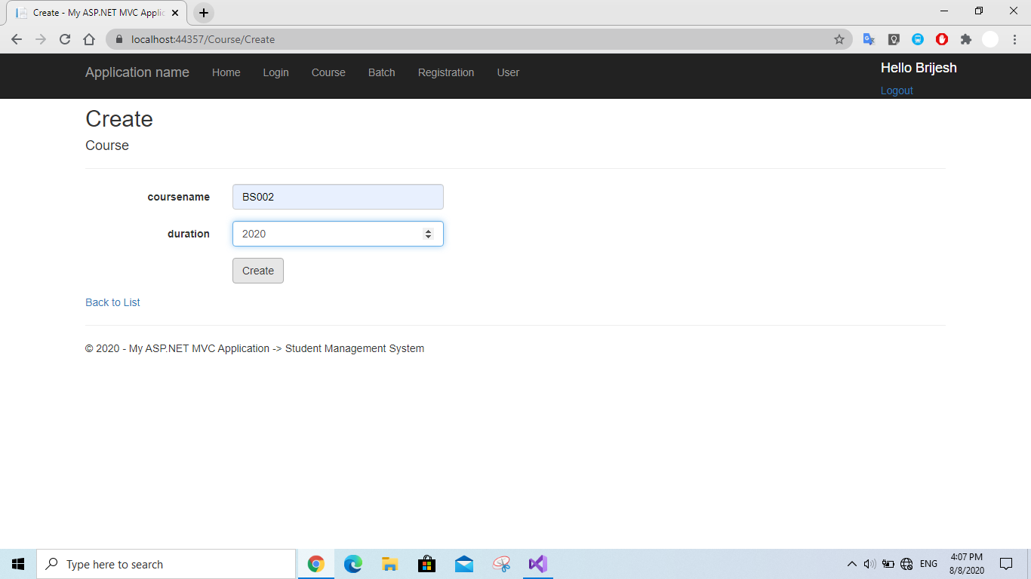

1. In ‘Batch’ you can add batch and year by clicking ‘Create’ button. You can find the list as well.

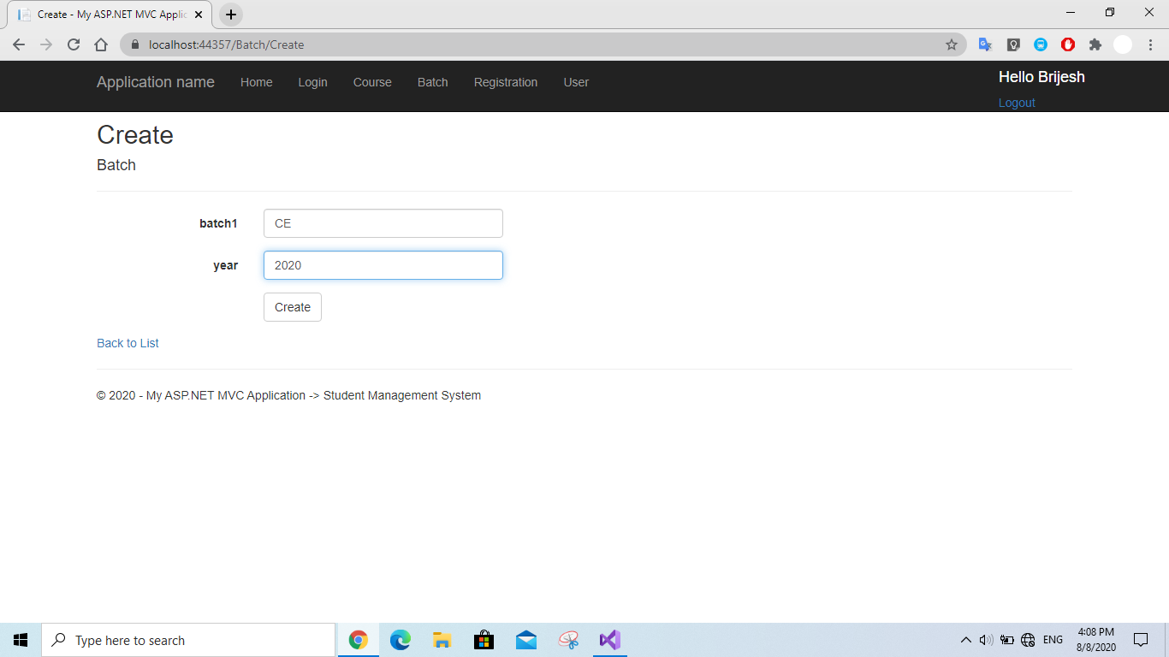

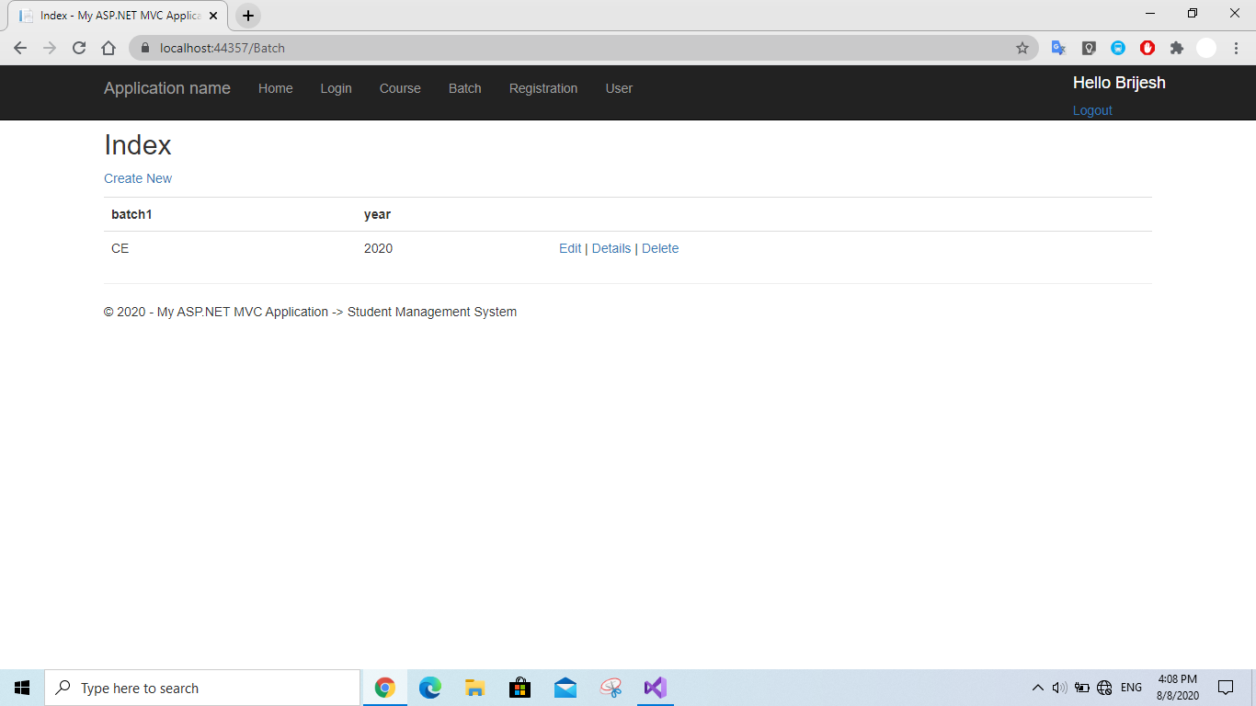

1. You can add Students and their details in ‘Registration Page’ by clicking ‘Create’ button.